Bid Specific Additional Terms and Conditions (ATC)

The following bid specific data shall amend and/or supplement the provisions in the GTC and specifications for “Procurement (Supply & Installation) of 06 Nos of Fire-Resistant Filing Cabinet (FRFC 4 dwr 2 Hr) for CTUIL Office at 5th –10th Floor, IRCON International Tower-1, Sector-32, Gurugram through Limited tender under PAC bidding (reserved for M/s Godrej authorized dealers) on GeM portal”:-
Sl.  No. | GTC Clause  Ref. No. | Amendment/Supplement to GTC
1 | GTC Clause 2(f) | Supplementing GTC Clause 2(f) with the following:  Buyer shall also mean CTUIL/Employer/Owner.  Address of the Employer/Buyer:  Kind Attn.: Ch.Manager (C&M)/Engineer (C&M)  10th floor, CENTRAL TRANSMISSION UTILITY OF INDIA LIMITED (CTUIL), IRCON INTERNATIONAL TOWER,  TOWER-1, SECTOR-32, GURGAON-122003  e-mail ID: virendra2@powergrid.in/akhil24@powergrid.in  Contact No.: 9599814158
2 | GTC Clause 2.0 (m) | Insert new clause after GTC 2.0(l) as per the following:  m. “Officer-in-Charge / Engineer-in-Charge/ Single Point of Contact (SPOC)” shall mean the Engineer/Officer/Administrative Officer, appointed by the Buyer or his duly authorized representative who shall direct, supervise and be in-charge of the works/supply for purpose of this contract.  HoD (HR) or his authorized representative (CTUIL) will be the Engineer-in-charge for subject Contract.
3 | GTC clause 4.0, xiii[f(i)] | Supplementing GTC clause 4.0, xiii[f(i)] with the following:  VALIDITY OF PROPOSAL:  a) Proposals shall remain valid for the period of 180 (One Hundred and Eighty) days from the bid submission end date. Any proposal valid for a shorter period shall be rejected by the Employer as being non-responsive.  b) In exceptional circumstance, the Employer may solicit the Bidder’s consent to an extension of the proposal validity period. The request and responses thereto shall be made through GeM. If a Bidder accepts to prolong the period of validity, the validity of proposal security shall also be suitably extended. A Bidder may refuse the request without forfeiting its proposal security. A Bidder granting the request will not be required or permitted to modify its proposal.
4 | GTC clause 3A (xix) | Supplementing GTC clause 3A (xix) with the following:  The bidder has to be a ‘Class-I local supplier’ as defined under Public Procurement (Preference to Make in India) Order, 2017 issued by Department for promotion of Industry and Internal Trade (DPIIT), Ministry of Commerce and Industry, Government of India vide order dated 15/06/2017, its revision dated 16/09/2020 (PPP-MII Order) read in conjunction with ‘Public Procurement (Preference to Make in India) to provide for Purchase Preference (linked with local content) in respect of order dated 02.07.2018 and 15.03.2022 issued by Ministry of Electronics & Information Technology (hereinafter MeitY order) and subsequent modifications/ amendments if any.  Presently, the local content requirement to categorize a supplier as ‘Class-I local supplier’ is minimum 50%.  Further, entities of countries which have been identified by the Nodal Ministry/Department identified under PPP-MII order, as not allowing Indian companies to participate in their Government procurement for any item related to that Nodal Ministry shall not be allowed to participate in bidding for all items related to that Nodal Ministry/Department, except for the list of items published by the Ministry/Department permitting their participation. The term ‘entity’ of a county shall have the same meaning as under the FDI Policy of DPIIT as amended from time to time.  The ‘Class-I local supplier’ shall give a self-certification in his bid in the given format, indicating the percentage of Local Content and certifying that the item offered meets the Local Content requirement for ‘Class –I local supplier’ and shall give details of the location(s) at which value addition is made. Further, in case of packages above Rs. 10 Cr, the ‘Local supplier’ shall provide a certificate from statutory auditor or cost auditor of the company (in the case of companies) or from a practicing cost accountant or practicing chartered accountant (in respect of suppliers other than companies) giving the percentage of Local Content. Any false declaration regarding Local Content by the bidder shall be a transgression of Integrity Pact/Code of Integrity and action shall be taken in line with provisions of GeM Terms & Conditions and in line with the provisions of the PPP-MII Order.
5 | GTC clause 19 | Supplementing GTC clause 19 with the following:  Seller/Firms, who are executing contract(s) or has executed contract(s) in the past for the Employer and any of the following event(s) have been encountered during contract(s) execution, shall not be eligible to bid for the package(s) whose originally scheduled date of bid opening falls within the specified period reckoned from the date of determination by the Employer of such event as below:  The Employer shall be the sole judge in this regard and the Employer’s interpretation on the aforesaid event(s) shall be final and binding.  Notwithstanding the above, in case any of the event(s) as per above table is encountered afresh even prior to opening of Second Envelope/Price Part Bid of any package, the bid of such bidder shall be considered as non-responsive/not eligible for that package.
  Sl. No. | Event | Period for which proposal(s) / bid(s) shall be considered as non-responsive/ not eligible
  1. | Termination of Contract due to Seller’s / Contractor’s default | 1 year
  2. | Encashment of CPG due to non-performance | 1 year
  3. | Firm has been referred to NCLT under Insolvency & Bankruptcy Code (IRP has been appointed or Liquidation proceedings have been initiated under IBC) | Till the firm comes out of Resolution process
6 | GTC clause 5 | Supplementing GTC clause 5.0 with the following:  A. GEM CONTRACT ORDER:  i. Prior to the expiration of the period of Proposal validity, the Employer will notify the successful Bidder through GeM Portal in the form of GeM Contract Order that its proposal has been accepted. The GeM Contract Order will constitute the formation of the contract.  ii. The Employer shall publish the results on its website, identifying the proposal and Specification numbers and the following information: (i) name of each Bidder who submitted a proposal; (ii) name of responsive Firms after evaluation of First Envelope; (iii) name of the winning Firm, and the price it offered.  iii. The Employer shall promptly respond in writing to any unsuccessful Bidder who, after GeM Contract Order in accordance with above, requests in writing the grounds on which its proposal was not selected.
7 | GTC clause  6.0 (ii) | Supplementing GTC clause 6.0(ii) with the following:  - Bidders are requested to quote the price in GeM portal itself. The bid price shall include all the costs for the entire scope of work as per the Bidding Documents.  - The Bid Prices quoted by the bidders covers all the Contractor’s obligations mentioned in or to be reasonably inferred from the Bidding Documents to successfully execute the intended services/supply, on a “Single Responsibility” basis. Bidders are required to quote the price for the commercial, contractual and technical obligations outlined in the Bidding Documents.  - DISCREPANCIES AND ADJUSTEMNT OF ERRORS:  - The Bidder should ensure that the price(s) furnished at more than one place in the proposal is consistent with each other.  - In case of any discrepancy between the Lump Sum quoted price on the GeM portal and uploaded Price breakup by the bidder, the Lump Sum quoted price on the GeM portal shall prevail. In such case, the Employer shall ask the L1 bidder for revised price breakup for matching the total quoted Lump Sum price on the GeM portal, through e-mail.  Bidders are advised to not upload the price bid in the technical part, otherwise bid submitted by such bidders will be rejected.  - A Proposal determined as not substantially responsive will be rejected by the Employer and may not subsequently be made responsive by the Bidder by correction of the non-conformity.  The Bidder should note that any deviation to RfP Documents and its subsequent Amendment(s)/ Clarification, found anywhere in bidder’s Proposal, implicit or explicit shall stand unconditionally withdrawn, without any cost implication whatsoever to CTUIL.  Bidders are advised to not upload the price bid in technical part, otherwise bid submitted by such bidders will be rejected.
8 | GTC Clause 7(ii) | Supplementing the referred provision of GTC with the following:  CPG as per Rate contract signed between Godrej and Powergrid
9 | GTC clause 12 | Replacing GTC clause 12.0 with the following:  PAYMENT TERMS:  100% payment shall be released within 15 days after supply/installation of material on submission of invoices along with other relevant documents. However, in case of site not ready (SNR) situation, CTUIL/POWERGRID may release 90% payment on delivery (on certification of Engineer-in-charge) after a waiting period of 21 days looking into the merit of the case and balance 10% on final installation and acceptance of material.
10 | GTC clause 14 | Supplementing GTC clause 14.0 with the following:  Completion Schedule/Completion period [including Supply, Installation and Commissioning (SIC)]:  Within 4 weeks from the date of LOA/GeM Contract Order.  Delivery & Installation Site/Location:  5th to 10th floor, Central Transmission Utility of India Limited, IRCON International Tower, Tower-1, Plot No. 16, Sector-32, Gurugram.
11 | GTC Clause 15(iii) | Replacing GTC clause 15(iii) with the following:  Liquidation Damages (LD):  In case M/s Godrej/ seller fail to supply any material as per given time schedule in any particular contract, they shall be liable to pay a sum equivalent to 0.05% [zero point zero five percent] payable thereon of the Contract Price of undelivered goods or the services as liquidated damages for such default and not as a penalty, without prejudice to the purchaser’s other remedies under the contract, for each day of delay until actual delivery or performance subject to the limit of 10% [Ten percent] thereon of Contract Price.
12 | GTC clause 16 | Supplementing GTC clause 16 with the following:  A SETTLEMENT OF DISPUTE  (i) If any dispute of any kind whatsoever shall arise between the Employer and the Contractor in connection with or arising out of the Contract, including without prejudice to the generality of the foregoing, any question regarding its existence, validity or termination, or the execution of the Facilities, whether during the progress of the Facilities or after their completion and whether before or after the termination, abandonment or breach of the Contract, the parties shall seek to resolve any such dispute or difference, to the extent possible, amicably by mutual consultation.  (ii) If the parties fail to resolve such a dispute or difference by mutual consultation, then the dispute shall be referred by the Contractor to the Engineer In Charge (EIC), who, within a period of thirty (30) days after being requested by Contractor to do so, shall give written notice of his decision.  (iii) The decision/instruction of the Engineer In Charge (EIC) shall be deemed to have been accepted by the Contractor unless notified by the Contractor of his intention to refer the matter for Arbitration/Conciliation within thirty (30) days of such decision/instruction.  (iv) In the event the Engineer In Charge (EIC)fails to notify his decision as aforesaid within thirty (30) days, the Contractor, if he intends to go for Arbitration/Conciliation, shall notify his intention to the Engineer In Charge (EIC)within 30 days of expiry of the first mentioned period of thirty days failing which it shall be deemed that there are no dispute or difference between the Employer and the Contractor.  (v) In case of dispute or difference between the Employer and the Contractor, if the Employer intends to go for Arbitration/Conciliation, he shall notify such intention to the Contractor.  (vi) All disputes or differences in respect of which the decision, if any, of the Engineer In Charge (EIC) and/or the Head of the Implementing Authority has not become final or binding as aforesaid shall be settled by arbitration/conciliation in the manner provided herein below.  - ARBITRATION  (i) In the event of any question, dispute or difference arising out of or in connection with this work, whether during the progress of the work after its completion, abandonment or breach of contract, the same shall be referred for arbitration.  The arbitration shall be conducted by a sole arbitrator in case the amount of claim is less than Rs. 25 Crore and by three member arbitral tribunal in case the amount of claim is greater than Rs. 25 Crore.  Sole Arbitration  The sole Arbitrator shall be chosen from a panel of empanelled Arbitrators maintained by POWERGRID/CTUIL. The same shall comprise of retired Judges and retired Senior executives of PSUs other than POWERGRID/CTUIL. Further, the choice of sole Arbitrator shall be governed by the amount of claim in the following manner:  - In case of invocation of arbitration by CTUIL, CTUIL shall, within 30 days, send a list of names of 3 arbitrators from its list/database of Arbitrators and the contractor shall within the period of further 30 days select any one person to act as “Sole Arbitrator”, which will be confirmed by CTUIL and matter will be referred to such appointed Arbitrator for further arbitration proceedings.  - In case of invocation of arbitration by the Contractor, the Contractor shall request CTUIL for its database of Arbitrators/ chose from the list of Arbitrators available on POWERGRID’s/CTUIL’s website, and the contractor shall, within 30 days, select any one Arbitrator from the above to act as “Sole Arbitrator”, which will be confirmed by CTUIL within 30 days and matter will be referred to such appointed Arbitrator for further arbitration proceedings.  If the parties fail to appoint sole arbitrator within sixty (60) days after receipt of a notice from the other party invoking Arbitration, the appointment of sole arbitrator shall be done by Courts as per the provisions of Indian Arbitration and Conciliation Act, 1996 or any statutory modification thereof.  Three member arbitral tribunal  The arbitration shall be conducted by three arbitrators, who are retired High Court/Supreme Court Judges, one each to be nominated by the Contractor and the Employer and the third to be appointed by both the arbitrators in accordance with the Indian Arbitration & conciliation Act. If either of the parties fails to appoint its arbitrator within sixty (60) days after receipt of a notice from the other party invoking the Arbitration clause, the arbitrator appointed by the party invoking the arbitration clause shall become the sole arbitrator to conduct the arbitration. In case of failure of the two arbitrators appointed by the parties to reach upon a consensus regarding appointment of presiding Arbitrator, within a period of 30 days from the appointment of the arbitrator appointed subsequently, the presiding arbitrator shall be appointed by Courts as per the provisions of Arbitration & conciliation Act.  (ii) The cost of arbitral proceedings inter-alia including the Arbitrators’ fee, logistics and any other charges shall be equally shared by both parties.  In case of Sole Arbitrator, the fees to be paid to the sole Arbitrator shall be as per the terms of empanelment in POWERGRID/CTUIL whereas in case of the three member tribunal, the Arbitrator’s fees shall be as agreed upon by the Arbitrators in line with the Arbitration & Conciliation Act. However, the expenses incurred by each party in connection with the preparation, presentation, etc. of its proceedings shall be borne by each party itself.  (iii) The language of the arbitration proceedings and that of the documents and communications between the parties shall be English. The arbitration shall be conducted in accordance with the provisions of the Indian Arbitration and Conciliation Act, 1996 or any statutory modification thereof. The venue of arbitration shall be New Delhi.  (iv) The decision of the sole arbitrator/ the majority of the arbitrators, as the case may be, shall be final and binding upon the parties. In the event of any of the sole arbitrator/ any of the aforesaid arbitrators dying, neglecting, resigning or being unable to act for any reason, it will be lawful for the parties to nominate another sole arbitrator/ another arbitrator in place of the outgoing arbitrator.  (v) Notwithstanding the above, in case the contractor is a Central Public Sector Enterprise (CPSE)/Government Organization or Department then the dispute/ difference (other than those related to taxation matters) between the Employer and the Contractor shall be settled through Administrative Mechanism for Resolution of CPSEs Disputes (AMRCD) as mentioned in DPE OM No. 4(1)/2013-DPE(GM)/FTS-1835 dated 22.05.2018 and DPE OM No. DPE-GM-05/0003/2019-FTS-10937 dated 20.02.2020. The decision through AMRCD will be final and binding on all the concerned.  (iv) During settlement of disputes and arbitration proceedings, both parties shall be obliged to carry out their respective obligations under the Contract.  - CONCILIATION  - The mechanism of Dispute resolution through Conciliation shall be available in cases where the amount involved in the dispute exceeds INR 1 Cr.  - The settlement of Disputes through conciliation mechanism shall be done by the Conciliation Committee of Independent Experts (CCIE) constituted by Ministry of Power, Govt. of India as per the procedure outlined in its OM dated 29.12.2021 as detailed herein below and its subsequent amendments/modifications (if any).  (a) Each member of CCIE would be paid a sum of Rs. 50,000/- as sitting fee per sitting. In addition, Rs. 5,000/- per sitting will be paid for local transport charges for each day of proceeding. The conciliation proceedings shall be completed in each case through 5 sittings in a period of not more than three months from the date the reference made to the CCIE. In exceptional cases, if any dispute so merits, the time period may be extended at the discretion of Conciliation Committee (with reasons to be recorded in writing), for a further period of three months. In case, a particular dispute requires more than 5 sittings, the same may be held at the discretion of the CCIE but with a cap on payment of fee for 5 sittings only. The local transport charges shall, however, be paid as provided for each day of sitting beyond the 5 sittings.  (b) The CCIE shall hold day to day sitting at the Headquarter of the Employer or New Delhi and may hold as many sittings every month as it deems appropriate keeping in view the volume of work.  (c) All expenditure incurred on the conciliation proceedings including payment of fees to the Conciliators, office space, logistic, secretarial assistance and other incidental expenses etc. shall be borne by the Employer initially. Thereafter it shall be shared equally by both parties on completion of the conciliation process.  - The procedure of CCIE shall not be treated as alternate arbitration proceedings where both parties come with Statement of claims/defence, arguments/counter arguments, rejoinders, written submissions etc., aided by their respective lawyers. The forum of CCIE is a conciliation forum, where mutual give and take constitutes the essence, rather than strict legal positions of the parties. Hence, the parties are expected to be brief and to the point before the committee with regard to their respective stance and view the exercise in the spirit of conciliation / settlement.  - The Standard Operating Procedure for the conciliation mechanism shall be as follows:  - On receipt of a reference from the Contractor for conciliation of dispute, the concerned Executive Director of the Employer shall send a communication within 7 working days thereby inviting the Contractor to depute a team of their representatives to interact with the Employer to crystallize the issues and prepare the agenda containing the gist on each dispute.  - Once a conciliation request has been raised by the contractor, within 30 days the same shall be referred to the CCIE in the event of the matter remaining unresolved internally.  - The Employer will also be free to suggest the option of resolution of disputes by conciliation in case a dispute has arisen. The contractor may select any one of the CCIEs as constituted by MOP after leaving out those CCIEs which are unavailable due to work load or any other reason as maintained by Central Electricity Authority (CEA),  - The Conciliation process shall be conducted under Part III of the Arbitration and Conciliation Act, 1996.  - The Conciliation Committee would either be able to resolve and settle the dispute(s) between the parties, or the process may fail.  - In the event of the conciliation proceedings being successful, the parties to the dispute would sign the written settlement agreement and the conciliators would authenticate the same. Such settlement agreement would then be binding on the parties in terms of Section 73 of the Arbitration and Conciliation Act, 1996.  - After successful conclusion of Conciliation, proceedings, the Parties to the conciliation process, have to undertake and complete all necessary actions for implementation of the terms of settlement within a period of 30 days from execution of settlement agreement, unless a different timeline not exceeding 60 days is agreed upon in settlement agreement. All pending claims of parties, in connection with the dispute, before any other legal forum are to be withdrawn within the said 30 days in pursuance of the settlement agreement.  - In case of failure of the conciliation process at the level of the Conciliation Committee, the parties may withdraw from conciliation process and take recourse to Arbitration proceedings or the laid down legal process of Courts.  - In cases of disputes pending before the Arbitration Tribunals or the Courts, both the parties (i.e. Employer and Contractor) need to agree to explore the possibilities of conciliation through the Conciliation Committee of Independent Experts. In case of such agreement, an appropriate reference shall be made to the Conciliation Committee, upon which the Committee shall proceed to examine such reference(s). In the event of the conciliation proceedings being successful, the parties to the dispute would sign the written settlement agreement and the conciliators would authenticate the same. Such settlement agreement would then be binding on the parties in terms of Section 73 of the Arbitration and Conciliation Act, 1996. However, the parties may resume the Arbitration proceedings or take recourse to any other legal remedies in the event of the conciliation proceedings not being successful.  During settlement of disputes and conciliation proceedings, both parties shall be obliged to carry out their respective obligations under the Contract.
  Sl no | Claim amount | Work Experience/Qualifications
  1 | < Rs. 10 Crore | Sole arbitrator-Retired Senior Executives of PSUs other than POWERGRID or CTUIL/Retired Distt Judges/ High Court Judges.
  2 | Rs.10 Crore- Rs.25 Crore | Sole arbitrator- Retired High Court/Supreme Court Judges
13 | GTC Clause 23 | Insert a new clause 23.6 & 23.7 of GTC with the following:  23.6 FRAUD AND CORRUPT PRACTICES  23.6.1 It is the Employer’s policy that requires the bidder to sign a declaration alongwith its bid about abiding by a ‘Code of Integrity for Public Procurement’. This policy is attached as Annexure-B.  23.6.2 In pursuance of this policy, the Employer:  - will take appropriate measures in line with the above policy if it determines that the bidder recommended for award has, directly or through an agent, has violated this Code of Integrity in competing for the contract in question; and  - will have the right to require that the provision be included in Bidding Documents and in contracts, requiring Bidders, suppliers, and contractors and their sub-contractors to permit the Employer to inspect their accounts and records and other documents relating to bid submission and contract performance and to have them audited by auditors appointed by the Employer.  23.7 WHISTLE BLOWER AND FRAUD PREVENTION POLICY  23.7.1 The Contractor along with its associate/Collaborators/Sub-contractors/sub-vendors/ consultants/ service providers shall strictly adhere to the Whistle Blower and Fraud Prevention Policy of Employer displayed on its tender website https://apps.powergrid.in/pgciltenders/u/default.aspx and https://www.powergrid.in/index.php/en/code-conductpolicies.  The contractor along with their associate/Collaborators/Sub-contractors/sub-vendors/ consultants/ service providers shall observe the highest standard of ethics and shall not indulge or allow anybody else working in their organisation to indulge in fraudulent activities during execution of the contract. The contractor shall immediately appraise the Employer about any fraud or suspected fraud as soon as it comes to their notice
14 | GTC clause 4.0, xiii(w) | Supplementing GTC clause 4.0, xiii(w) with the following:  - CLARIFICATION OF PROPOSALS  During proposal evaluation, the Employer may, at its discretion, ask the Bidders for clarification of its proposal. In case of erroneous/non-submission of documents related to/identified related to Attachment 1 to 10 and complete annual reports of Last three financial years together with Audited statement of accounts, Online Payment acknowledgment towards Bid Security (in cases where online payment has been made prior to the deadline for submission of hardcopy part of the bids), documentary evidence with regard to registration with designated Authority of GoI under the Public Procurement Policy for MSEs submitted by the Bidders as per the provisions of the bidding Documents/GeM policy, the Employer may give the bidders not more than ’07 days’ notice to rectify/furnish such documents, failing which the bid/proposal is liable to be rejected. The request for clarification and response shall be in writing, and no change in the price or substance of the proposal shall be sought, offered or permitted. So far as the submission of documents is concerned with regard to qualification criteria, after submission of the tender, only related shortfall documents should be asked for and considered. For example, if the bidder has submitted a supply order without its completion/performance certificate, the certificate can be asked for and considered. However, no new supply order should be asked for so as to qualify the bidder.  In case of non-submission of documents related to/identified in Attachment-7 {‘Information regarding ex-employees of Employer in Bidder’s firm’}, the Employer may give the Bidder not more than 7 days’ notice to rectify/furnish such documents, failing which Employer reserves the right to reject such bids. Employer shall be the sole judge in this regard.  - AMENDMENT OF BID DOCUMENTS  At any time prior to the deadline for submission of bids, CTUIL may, for any reason, whether at its own initiative, or in response to a clarification requested by a prospective Bidder, amend the bid documents.  The amendment will be notified only through the GeM Portal. The communication/ alert regarding the notification of amendment shall also be sent by the portal directly to all the prospective bidders. The amendments to the bid documents will be binding on the bidders and the notification of the amendment through portal, sent to the prospective bidders, shall be deemed to be construed that such amendment(s) to the bid documents have been considered by the Bidder in its bid.  In order to afford reasonable time to the prospective bidders to take the amendment into account in preparing their bid, the Employer may, at its discretion, extend the deadline for the submission of bids, in which case, the Employer will notify through GeM Portal, where all prospective bidders may see the extended deadline.  - DOCUMENTS COMPRISING THE PROPOSAL:  The proposal shall comprise of the following documents to be uploaded on the portal as per the provisions therein:  a) As part of First Envelope  The following attachments as given in bid documents:  The complete information sought above with any additional information considered necessary by the Bidder as a part of the Proposal, should be submitted.  Scanned copies of Attachmnet-1 to 10 of any other documents to be submitted/uploaded along with the GeM bid which bidder/seller consider relevant.  Uploading Price Bid in any form with first envelope proposal will be at the Bidder’s/Seller’s risk and may result in rejection of its proposal.  (b) As part of Second Envelope  Price bid shall be fill/uploaded on GeM portal only as per GeM guidelines.  The Bidders shall upload the break-up of Price Schedule/Price bid on GeM portal as per GeM guidelines/procedure along with applicable GST (it should not be the part of 1st Envelope/Tech bid). Format for Price breakup is available with the bid documents.  Submission of Soft Copy of any documents by any other means shall not be accepted by the Employer in any circumstances.  Bidders shall note that no document is required to be submitted as part of Second envelope in Hard Copy.  Scope of Work:  Supply & Installation of 06 Nos of Fire- Resistant Filing Cabinet (FRFC 4 dwr 2 Hr) for CTUIL Office at 5th –10th Floor, IRCON International Tower-1, Sector-32, Gurugram.  GODREJ shall offer free of cost maintenance/repair services as and when required to Furniture Items/Office Equipment’s, three times a year for all the items procured from GODREJ by POWERGRID. During maintenance/repair services, if any spare is required, GODREJ shall supply the same at a discount@15% on prevailing rate.  Guarantee Period:  All Godrej products shall be guaranteed against any manufacturing defect for a period of 12 [Twelve] months from the date of supply.
  (a) | Attachment 1 | : | Declaration by the bidder for ‘Code of Integrity for Public procurement’ (uploading of Scanned Copy)  The bidder shall furnish in its bid the declaration about abiding by a ‘Code of Integrity for Public Procurement’ in accordance with relevant clause of bid document.  Bidder’s failure to submit the ‘Declaration for Code of Integrity for Public procurement’ along with the Bid or subsequently pursuant to relevant clause of bid document shall lead to outright rejection of the Bid.  Format enclosed as Attachment-1 below.
  (b) | Attachment 2 | : | Information for E-payment, PF details and declaration regarding Micro/Small & Medium Enterprises (uploading of Scanned Copy)
  (c) | Attachment 3 | : | Power of Attorney (submission of Hard Copy in ‘Original’ and uploading of Scanned Copy)  A power of attorney, duly notarized, indicating that the person(s) signing the Proposal has(ve) the authority to sign the Proposal and thus the Proposal is binding upon the Bidder during full period of its validity.  Further, Bidder shall furnish copy of partnership deed, in case of partnership firm, Memorandum and Articles of Association, in case of limited company, ownership certificate in case of sole or proprietorship firm. (if applicable)  Bidder shall furnish this PoA in its own format.
  (d) | Attachment 4 | : | Certification by the Bidder as per DoE Order in line with clause no. 26 of GeM GTC (uploading of Scanned Copy)  Format enclosed as Attachment-6 below.
  (e) | Attachment 5 | : | Affidavit of Self certification regarding Minimum Local Content in line with PPP-MII order (submission of Hard Copy in ‘Original’ and uploading of Scanned Copy), to be submitted on a non-judicial stamp paper of Rs. 100/-.  In line with the PPP-MII order, the bidder shall submit the Affidavit of self-certification, in original, indicating the percentage of Local Content and certifying that the item offered meets the Minimum Local Content and shall give details of the location(s) at which value addition is made, as prescribed in the PPP-MII Order, on a non-judicial stamp paper of Rs. 100/-.  Further, Self-certification submitted by the bidder may be verified randomly by the committee constituted as per PPP-MII order. In case of false documents/ misrepresentation of the facts, requisite action against such bidder will be taken based on the recommendation of the committee and in line with provisions of the Integrity pact.  Bidder may note that the other directions of Nodal Ministry as identified under PPP-MII order shall also be suitably considered in regard to verification/ action of the certificate.  Format enclosed as Attachment-5 below.
  (f) | Attachment 6 | : | Declaration by the Bidder regarding events encountered pursuant to Clause 19 of GeM GTC (uploading of Scanned Copy)  Format enclosed as Attachment-8 below.
  (g) | Attachment 7 | : | Information regarding Ex-employees of CTUIL/ POWERGRID in our Organization (uploading of Scanned Copy)  Format enclosed as Attachment-9 below.
  (h) | Attachment 8 | : | KMP Declaration (uploading of Scanned Copy).
  (i) | Attachment 9 | : | Declaration by the bidder regarding “POWERGRID/CTUIL’s Whistle Blower and Fraud Prevention Policy”)  (uploading of Scanned Copy)  Format enclosed as Attachment-11 below.
  (j) | Attachment 10 |  | MAF (manufacturer authorization form)/OEM (Original Equipment Manufacturer) Certificate/form from the M/s Godrej & Boyce Mfg. Co. Ltd. (Godrej), (uploading of Scanned Copy),  CTUIL has not provided any specific format, bidder may submit the copy of OEM/MAF authorization as per the format of M/s Godrej & Boyce Mfg. Co. Ltd.,  (Only authorized dealers/channel partners of M/s Godrej & Boyce Mfg. Co. Ltd. are allowed to participate in the subject bidding)
15 | GTC clause 15(iv) | Supplementing GTC clause 15(iv) with the following:  M/s Godrej/seller shall not be responsible for any delay, if such delay is due to the act of GOD, Revolution, Embargo, Riots, Civil Commotion or Political disturbances, strikes, Lockouts, shortage of Labour through any cause, failure in the supplies for non-availability of adequate quantity of essential raw materials, like steel not be liable to claim for any compensation provided other party notify the other in writing within 15 days from such occurrences.
16 | GeM bid Disclaimer,  Sl. No. 6 | Disclaimer on GeM bidding:  As per GeM bid disclaimer, “Mandating submission of documents in physical form as a pre-requisite to qualify bidders”.  Further, it is mandatory for L1-bidder/seller to submit the hard copies of the following Documents/Attachments to the buyer’s above-mentioned Address before the placement of GeM Contract Order:  i. Attachment- 3  ii. Attachment-5  Scanned copies of the above-mentioned attachments have been uploaded/submitted by the bidders along with the GeM bid. However, the hard copies of the same to be submitted by L-1 bidder/Seller to buyer’s above-mentioned address, else the bid submitted by L1 bidder may be treated as incomplete & may lead to rejection of the bid by buyer without making any reference to the bidder/seller. Subsequently, the EMD of L1 bidder/Seller shall be forfeited.
17 | Special Condition of contract | Quantity Variation: The overall contract price may vary up to (+/-) 25% of awarded price for the items included in the Letter of Award, without any change in unit prices and other items terms and conditions. The quantities of individual items for any item may however, vary up to any extent.
14 | i. indicative Bill Of Quantity(BoQ)  ii. Technical Specification - Fire Resisitance Filing Cabinet (FRFC) :
  Sl No | Item | Quantity(nos.) | Rate Per Unit (Rs.) | GST | Total (Incl. GST)
  01 | Godrej Fire Resisitance Filing Cabinet (FRFC 4 dwr 2 Hr) + BIS | 6 | Prices to be quoted on GeM portal Only in line with the GeM policy.
   | Total
  Note: Price quoted will be inclusive of supply, installation, F&I and other accessories required for installation etc. (Delivery will be done on floor 5th - 10th as per requirement)
  Sl No | Item | Specification
  01 | Godrej Fire Resisitance Filing Cabinet (FRFC 4 dwr 2 Hr) + BIS | Fire Resistance for 60 min - 120 mins  * Endures temperature up to 1000C maintaning internal temperature withing 177C - heavy duty slides for easy & smooth operations of drawers having fire partition  * Unique interlocking system for independent drawer access  * Press-button release handle with built-in index panel on each drawer  * Tongue and groove construction prevents passage of hot gases into the drawers  * Snap-shut mechanism minimizes time taken to lock the cabinet during crisis * Proprietary In-fill material structure shields the cabinet from floor collapse- Additional locking options with Combination locks, electronic locks and Biometric locks.  * Tested and IS 14561:2014 certification.  Dimensions :159.9X55.1x83.5cm
15 | Drawing is attached below:
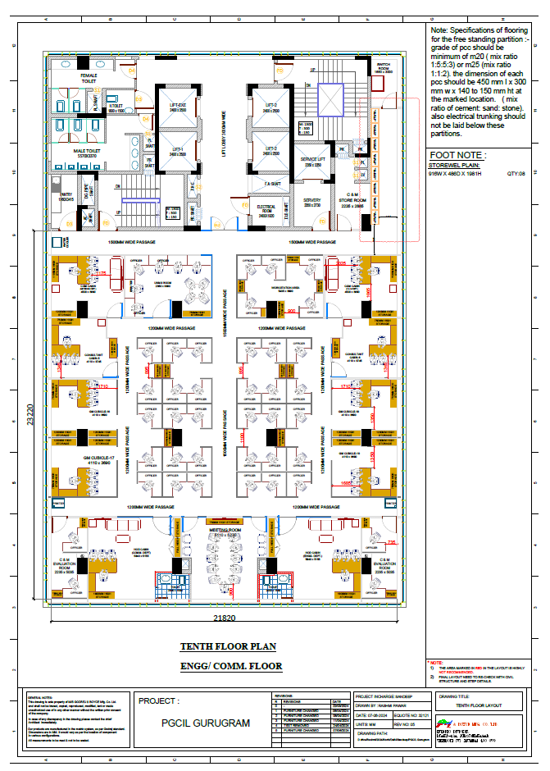
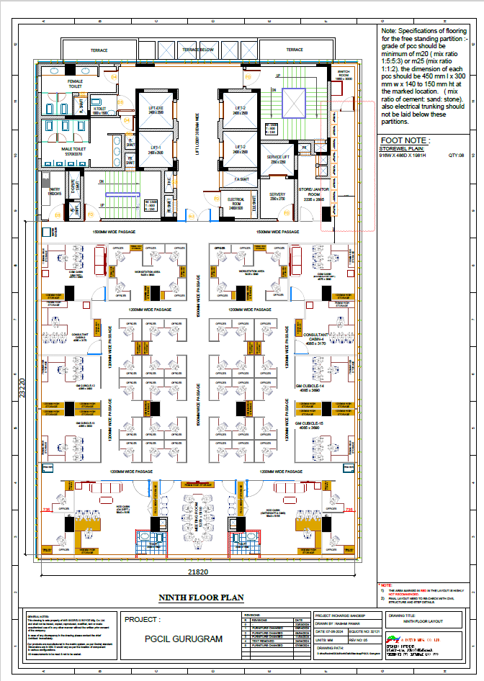
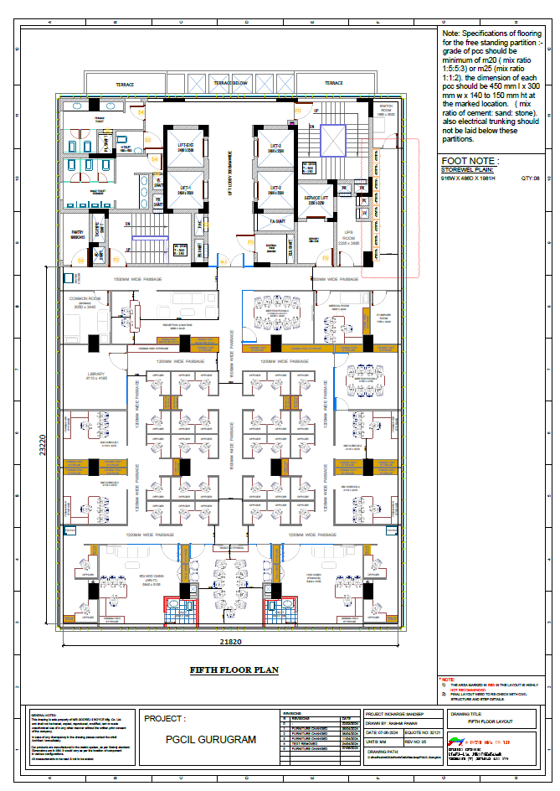
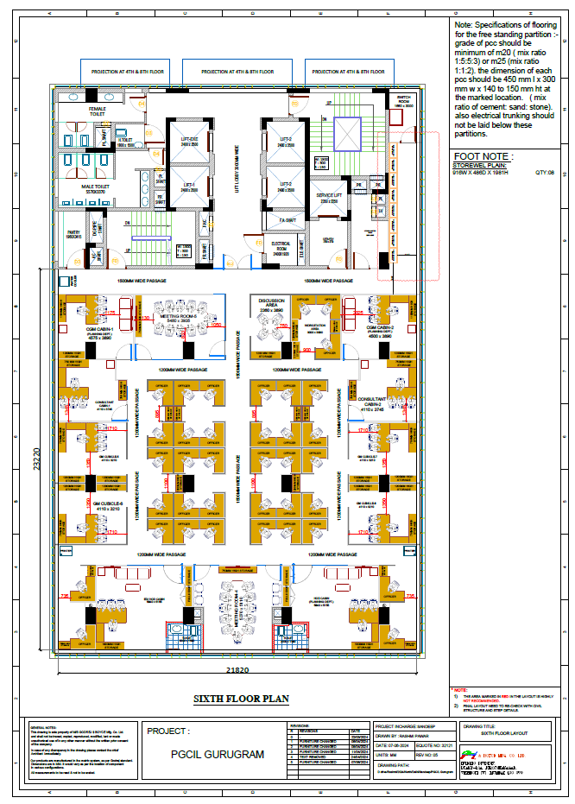

Attachment-1

GeM Bid No…………..

(Declaration by the bidder for ‘Code of Integrity for Public procurement’)

Bidder’s Name and Address:  Name :  Address : | To:  C&M  Central Transmission Utility of India Limited  (A wholly owned subsidiary of POWERGRID)  10th floor, IRCON International Tower-1, Plot No. 16  Sector-32, Gurugram – 122003, Haryana

Dear Sir,
- We have read the provisions of the bidding documents regarding abiding by the ‘Code of Integrity for Public Procurement’. Accordingly, we hereby declare that we shall abide by the ‘Code of Integrity for Public Procurement’ as mentioned under Clause no. ……of the Bidding Documents/ATC.

The details of any previous transgressions of the code of integrity with any entity in any country during the last three years or of being debarred by any other Procuring Entity are as under:

(a)

(b)

(c)

- We also accept that in case of violation/transgression of this code by us in competing for or in executing the Contract, Employer has the right to take punitive measures as per the provisions of the Bidding Documents and/or CTUIL/POWERGRID’s policy and procedure.

Date: |  | Name and Signature:
Place: |  | Designation:

Attachment-2

(Information for E-payment, PF details and declaration regarding Micro/Small & Medium Enterprises)

Bidder’s Name and Address:  Name :  Address : | To:  C&M  Central Transmission Utility of India Limited  (A wholly owned subsidiary of POWERGRID)  10th floor, IRCON International Tower-1, Plot No. 16  Sector-32, Gurugram – 122003, Haryana

Dear Sir,
We hereby authorize the Employer to make all our payments through Electronic Fund Transfer System. The details for facilitating the payments are given below: -
1 | Name of the Consultant in whose favour payment is to be made
2 | Address with PIN Code and State
2 | Registered Office:
2 | Correspondence Address:
3 | Name of Contact Person
3 | Designation
4 | Contact Details
4 | Landline(s):
4 | Mobile(s):
4 | Email ID :
5 | Status – Company/others  [Declaration of Micro/ Small/ Medium Enterprise under Micro/ Small & Medium Enterprises Development Act 2006, if applicable]
6 | Permanent Account (PAN) No.
7 | GSTIN No. | (i)  (ii)  (iii)
8 | PF Registration No. of the Company
9 | PF Regional Office covered (with Address)
10 | Bank Details for Electronic Payment
10 | Name of the Bank:
10 | Address of Branch:
10 | Account No.:
10 | Type of Account:  Current Account or Saving Account
11 | 9-digit MICR code printed at bottom in middle, next to cheque no.
12 | IFSC (for RTGS)/NEFT Code (to be obtained from the Bank) Sample Cancelled Cheque to be enclosed

I/We hereby declare that the particulars given above are correct and complete. If the transaction is delayed or credit is not affected at all for reasons of incomplete or incorrect information, I/We would not hold the employer responsible.

Date : |  | Printed Name :
Place : |  | Designation :

Attachment-3

(Bidder shall furnish the Power of Attorney (PoA) as per standard format regarding PoA.)

Attachment-4

(Certification by the Bidder as per order no. F.No.6/18/2019-PPD dated 23/07/2020 issued by Public Procurement Division, Department of Expenditure, Ministry of Finance, Government of India (DoE Order))

Bidder’s Name and Address:  Name :  Address : | To:  C&M  Central Transmission Utility of India Limited  (A wholly owned subsidiary of POWERGRID)  10th floor, IRCON International Tower-1, Plot No. 16  Sector-32, Gurugram – 122003, Haryana

Dear Sir,

We have read and understood the provisions of Order no. F.No.6/18/2019-PPD (Order Public Procurement no.1) dated 23/07/2020 regarding “Restriction under Rule 144(xi) of General Financial Rules” and F.No.6/18/2019-PPD (Order Public Procurement no.2) dated 23/07/2020 regarding “Exclusions from Restriction under Rule 144(xi) of General Financial Rules” issued by Public Procurement Division, Department of Expenditure, Ministry of Finance, Government of India [hereinafter collectively “DoE Order’’] and any subsequent modifications/Amendments, if any.

Particularly, we, the Bidder, have read the clause regarding restrictions on procurement from a ‘Bidder of a country which shares a land border with India’ and on sub-contracting to contractors from such countries.
We certify that we, the bidder is/are not from such a country or, if from such a country, has been registered as per provisions of above-mentioned order/guidelines with the Competent Authority and will not subcontract any work to a subcontractor/sub vendor from such countries unless such subcontractor/sub vendor fulfils all requirement in this regard and is eligible to be considered. [Where applicable, evidence of valid registration by the Competent Authority shall be attached.]

We further declare that any misrepresentation or submission of false/forged document/information in this regard shall be dealt with as per the provisions of GeM Terms & Conditions or Govt. Orders in this regards.

Date : |  | Printed Name :
Place : |  | Designation :

Attachment-5

…………….(name of the Package)……………………..

Format for Affidavit of Self certification regarding Local Content in line with PPP-MII order and MeitY Order, if applicable, to be provided on a non-judicial stamp paper of Rs. 100/-.
Date:

I S/o, D/o, W/o, Resident of hereby solemnly affirm and declare as under:

That I will agree to abide by the terms and conditions of the Public Procurement (Preference to Make in India) Order, 2017 of Government of India issued vide Notification No:P-45021/2/2017 -BE-II dated 15/06/2017, its revision dated 16/09/2020 (hereinafter PPP-MII order),

‘Public Procurement (Preference to Make in India) to provide for Purchase Preference (linked with local content)’ order dated 02.07.2018 and 15.03.2022 issued by Ministry of Electronics & Information Technology (hereinafter MeitY order)

and any subsequent modifications/Amendments, if any and

That the information furnished hereinafter is correct to the best of my knowledge and belief and I undertake to produce relevant records before the procuring entity/CTUIL or any other Government authority for the purpose of assessing the local content of goods/services/works supplied by me for
…………(insert name of the package)………….

That the local content for all inputs which constitute the said goods/services/works has been verified by me and I am responsible for the correctness of the claims made therein.

That the ‘Local Content ‘as defined in the PPP-MII order and MeitY order in the goods/services/works supplied by me for …………(insert name of the package) is percent (%).

That the goods/services/works supplied by me for …………(insert name of the package) meet the
‘Local Content‘ requirement as defined in the PPP-MII order and MeitY order for ‘Class –I local supplier’/‘Class –II local supplier’/.

That the value addition for the purpose of meeting the ‘Local Content ‘has been made by me at ………………
(Enter the details of the location(s) at which value addition is made).
That in the event of the local content of the goods/services/works mentioned herein is found to be incorrect and not meeting the prescribed Local Content criteria, based on the assessment of procuring agency (ies)/CTUIL/Government Authorities for the purpose of assessing the local content, action shall be taken against me in line with the PPP-MII order,MeitY order and provisions of the Integrity pact/ Bidding Documents.

I agree to maintain the following information in the Company's record for a period of 8 years and shall make this available for verification to any statutory authority.

i Name and details of the Local Supplier
(Registered Office, Manufacturing unit location, nature of legal entity)

- Date on which this certificate is issued

- Goods/services/works for which the certificate is produced

- Procuring entity to whom the certificate is furnished
- Percentage of local content claimed and whether it meets the Local Content prescribed for ‘Class – I local supplier’/‘Class –II local supplier’/.
- Name and contact details of the unit of the Local Supplier (s)
- Sale Price of the product
viii Ex-Factory Price of the product
- Freight, insurance and handling
- Total Bill of Material
xi List and total cost value of input used to manufacture the Goods/to provide services/in construction of works
- List and total cost of input which are domestically sourced. Value addition certificates from suppliers, if the input is not in-house to eb attached
- List and cost of inputs which are imported, directly or indirectly

For and on behalf of (Name of firm/entity)
Authorized signatory (To be duly authorized by the Board of Directors)
<Insert Name, Designation and Contact No.>

Attachment-6

(Declaration regarding events encountered pursuant to bid documents/GeM bid)

Bidder’s Name and Address:  Name :  Address : | To:  C&M  Central Transmission Utility of India Limited  (A wholly owned subsidiary of POWERGRID)  10th floor, IRCON International Tower-1, Plot No. 16  Sector-32, Gurugram – 122003, Haryana

Dear Sir,
1.0 In accordance with the relevant provisions of the RfP documents inter-alia including for assessment of capacity and capability, we furnish herewith our data/details/documents along with other information, as follows
Sr. No. | Event
1. | Whether there was Termination of Contract(s) due to Consultant’s /Contractor’s default | - Yes  - No
2. | Whether there was Encashment of CPG(s) due to non-performance | - Yes  - No
3. | Firm has been referred to NCLT under Insolvency & Bankruptcy Code (IRP has been appointed or Liquidation proceedings have been initiated under IBC) | - Yes@  - No
Note:
1. Information regarding events at Sl. No. 1 & 2 shall be furnished for events occurred during last one year under the contract(s) executed by you for CTUIL.
@2. Regarding Sl. No. 3, in case of ‘Yes’, following information shall be submitted additionally:
Date on which the firm has been referred to NCLT under Insolvency & Bankruptcy Code (IRP has been appointed or Liquidation proceedings have been initiated under IBC) | …………
Whether the process under IBC has been concluded  (If yes, supporting documents be submitted) | Yes  No
2.0 We confirm that the above information/declarations and documents submitted in support of the same are true and correct to the best of our knowledge. We understand that any false declaration and/or misrepresentation of facts and/or false/forged documents/information may lead to our debarment from participation in Employer tenders and that our Bid Security/Contract Performance Guarantee may be forfeited besides other actions as deemed to be appropriate as per the provisions of the RfP Documents/Integrity Pact.

Date : |  | Printed Name :
Place : |  | Designation :

Attachment-7

(Information regarding Ex-employees of CTUIL/POWERGRID in our Organization)

Bidder’s Name and Address:  Name :  Address : | To:  C&M  Central Transmission Utility of India Limited  (A wholly owned subsidiary of POWERGRID)  10th floor, IRCON International Tower-1, Plot No. 16  Sector-32, Gurugram – 122001, Haryana

Dear Sir,
We declare that we are aware of and have gone through the “Code of Business Conduct and Ethics for Senior Management Personnel” and “Code of Business Conduct and Ethics for Board Members” of POWERGRID (hereinafter referred to as the “Code of Conduct”). We further understand that as per the “Code of Conduct”, Senior Management Personnel including Board Members, who have retired/resigned from CTUIL/ POWERGRID, shall not accept any appointment or post, as detailed in the referred “Code of Conduct”, within 1 year from the date of cessation of service/directorship unless approved by the Competent Authority.

Accordingly, we hereby furnish the details of ex-employees of CTUIL/ POWERGRID who had retired/resigned at the level of General Manager and above from CTUIL/ POWERGRID and subsequently have been employed by us:

Sl. No. | Name of the person with designation in CTUIL | Date of Retirement/resignation from CTUIL/ POWERGRID | Date of joining and designation in our organisation*
1
2
3
Note: (*) In case the date of joining in the bidder’s organisation of such ex-employee is within 1 year from the date of retirement/resignation from CTUIL/ POWERGRID, No Objection Certificate/approval from the Competent Authority must be furnished along with the bid or subsequent through clarification pursuant to relevant clause of bid documents.
In case of non-submission of No Objection Certificate/approval from the Competent Authority, as required, we understand that CTUIL shall deal with such cases as per its policy and procedures of POWERGRID in vogue, which may also result in rejection of our bid. We also confirm that CTUIL shall be the sole judge in this regard.
We further declare that any misrepresentation or submission of false/forged documents/information in this regard shall be dealt with as per the provisions of the Bidding Documents and/or POWERGRID’s policy and procedures.

Date: | Name and Signature:
Place: | Designation:

Note:
- “Code of Business Conduct and Ethics for Senior Management Personnel” and “Code of Business Conduct and Ethics for Board Members” are available on POWERGRID’s website https://www.powergrid.in/.
- In case bidder has furnished no details on ex-employees of CTUIL/POWERGRID or has left blank or has indicated ‘-‘against the same, it shall be deemed that they have not employed any such person in their organization.

Attachment-8

…..…..Name of the Package……….

(Declaration of Key Managerial Person (KMP) and Power of Attorney holder)

Bidder’s Name and Address:  Name :  Address : | To:  C&M  Central Transmission Utility of India Limited  (A wholly owned subsidiary of POWERGRID)  10th floor, IRCON International Tower-1, Plot No. 16  Sector-32, Gurugram – 122003, Haryana

Dear Sir,

- We confirm that the declarations made in our proposal are true and correct to the best of our knowledge.
We also confirm that in support of meeting Technical Evaluation Criteria as per bid Documents/GeM bid, we have enclosed self-certified copy of documentary evidence in support of the above requirements.

- We shall furnish clarification to proposal, if any sought by Employer pursuant to bid documents/GeM bid. We understand that if we fail to rectify/furnish the requested documents if any, within 07 days’ notice, our proposal is liable to be rejected.

- We understand that any false declaration and/or misrepresentation of facts and/or furnishing of false/forged documents /information may lead to our debarment from participation in Employer tenders and that our Contract Performance Guarantee/ePBG may be forfeited besides other actions as deemed to be appropriate as per the provisions of the bid Document/GeM bid.

- Notwithstanding above, we also confirm that the Employer may verify the supporting documents/ details in connection with above declarations. We further understand that in case of any unethical practices inter-alia including any misrepresentation of facts, submission of false and/or forged details/ documents/ declaration by us, we may be debarred from the participation in Employer’s tenders in future as considered appropriate by Employer and our Contract Performance Guarantee/ePBG shall be forfeited besides taking other actions as deemed appropriate.

Date:....................
Place:...................
(Signature of Power of Attorney holder)...................................................………..
(Printed Name)..........................................………….
(Designation)................…………..............................
(Common Seal).…………..........................................

(Signature of Key Managerial Person)...................................................………..
(Printed Name)..........................................………….
(Designation)................…………..............................
(Common Seal).…………..........................................

Note: Key Managerial Personnel (KMP) of the company shall include CEO/Managing Director/ Company Secretary/ Director/ CFO/any of the partner in case of partnership firm/any other officer entrusted with substantial powers of the management of the affairs of the company/firm.

Attachment-9

(….. Package Name……)

(Declaration by the bidder for “POWERGRID/CTUIL’s Whistle Blower and Fraud Prevention Policy”)

Bidder’s Name and Address:  Name :  Address : | To:  C&M  Central Transmission Utility of India Limited  (A wholly owned subsidiary of POWERGRID)  10th floor, IRCON International Tower-1, Plot No. 16  Sector-32, Gurugram – 122003, Haryana

Dear Sir,

- We have read the provisions of the bidding documents regarding adhering the “POWERGRID/CTUIL’s Whistle Blower and Fraud Prevention Policy”. Accordingly, we hereby declare that we, along with our associate/collaborators/sub-contractors/sub-vendors/consultants/service providers shall strictly adhere to the “POWERGRID/CTUIL’s Whistle Blower and Fraud Prevention Policy” as mentioned under Clause no. ……of the Bidding Documents/ATC.

- We, along with their associate/Collaborators/Sub-contractors/sub-vendors/consultants/ service providers shall observe the highest standard of ethics and shall not indulge or allow anybody else working in our organization to indulge in fraudulent activities during execution of the contract and would immediately appraise the Employer about any fraud or suspected fraud as soon as it comes to our notice.

Date: |  | Name and Signature:
Place: |  | Designation:

